Pengujian postman API POST

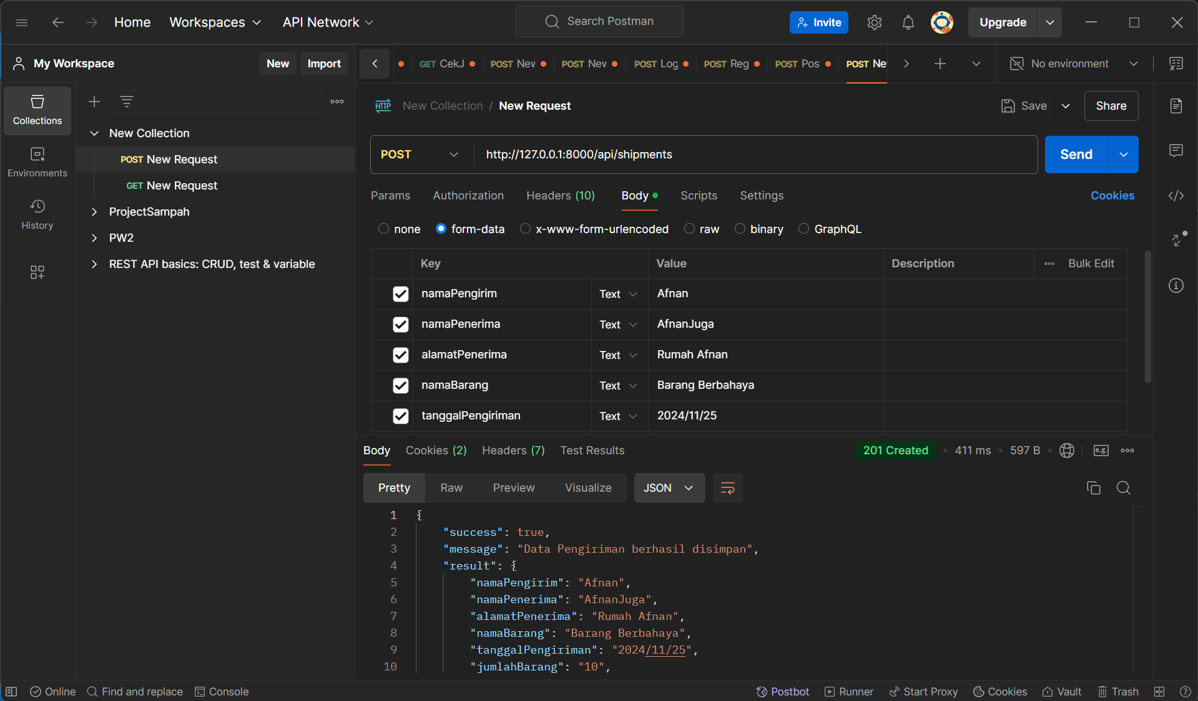

Pengujian postman API GET

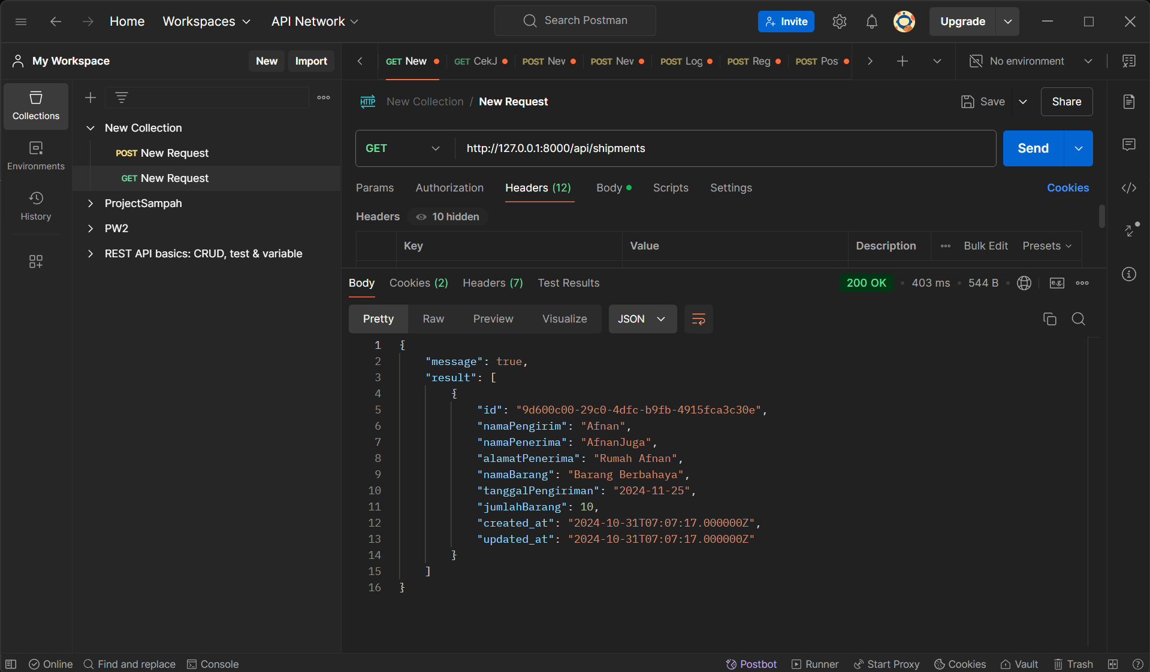

Tabel Pada phpMyAdmin clever cloud

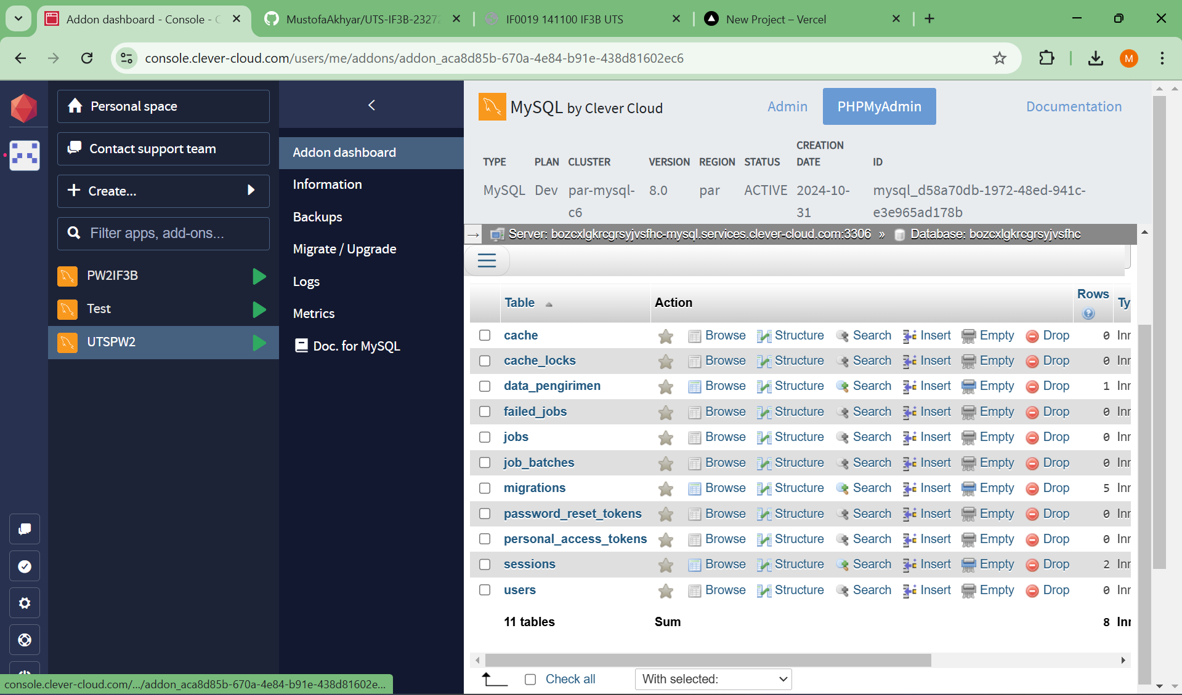

Deploy netlifly

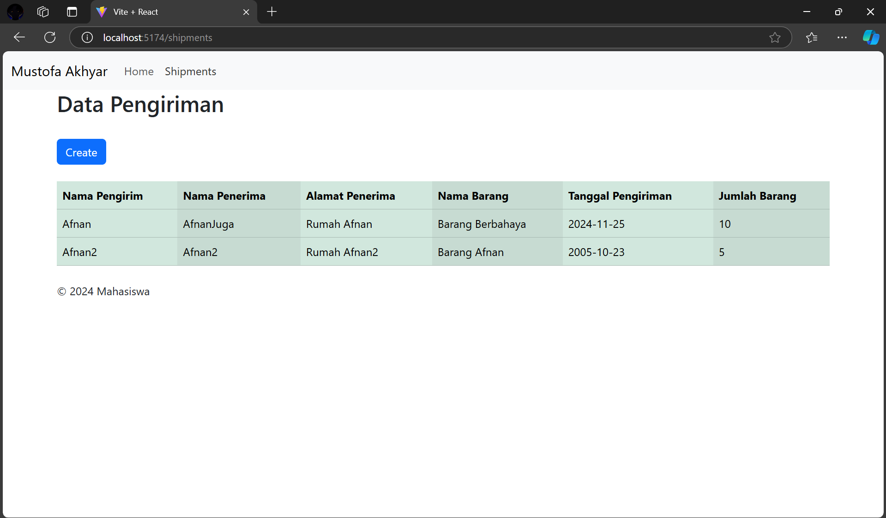

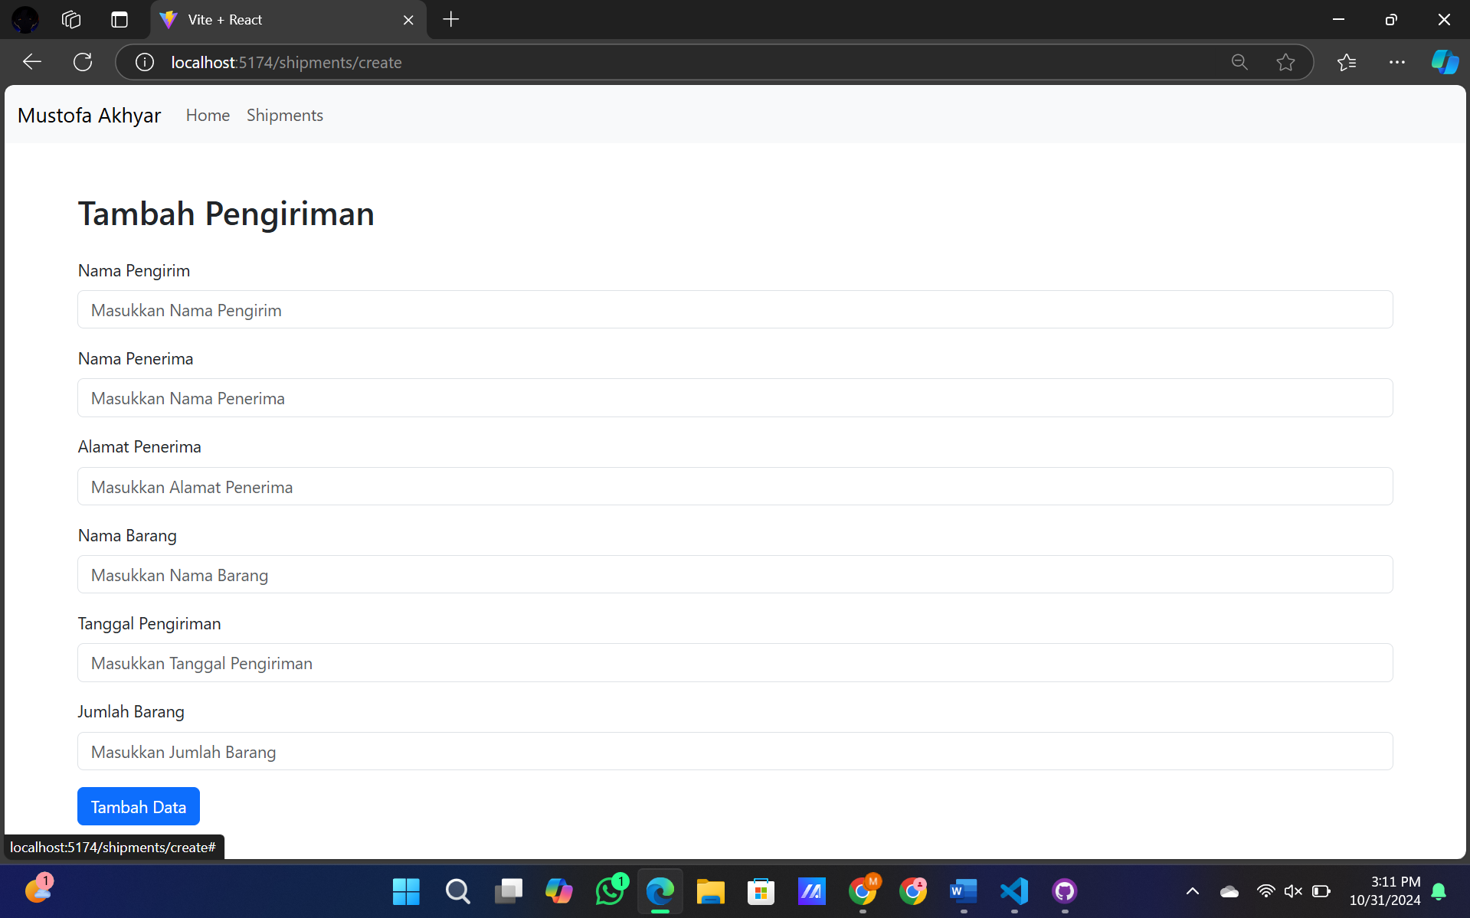

<https://github.com/MustofaAkhyar/UTS-IF3B-2327250016-REACT>

<https://github.com/MustofaAkhyar/UTS-IF3B-2327250016-API>